Helmerich & Payne
H&P - Azure Service Principal

SPN Management/Monitoring

Revision History

Date of Change | Revision Number | Description of Changes | Responsible
12/10/18 | 1.0 | Initial Release | John Perry
08/22/19 | 1.1 | Update for H&P | David Smith

Overview
H&P wishes to monitor a variety of features surrounding the use of Azure Service Principals (SPs) also sometimes called Application IDs (AppIDs). The main target of monitoring is the key (aka password) expiration. This document is a summary of recommendations and details about the process.

Installation

Service Principal Creation
Azure Service Principals (SPs) can be created in numerous ways: via the Azure Portal, Azure
CLI, or Powershell.

Instructions on how to create an SP via the Azure Portal can be found:

Azure Portal Instructions: [https://docs.microsoft.com/en-us/azure/azure-resource-manager/resource-group-create-service-principal-portal]

Instructions for creating SPs via the command line can be found:

Azure CLI Instructions: [https://docs.microsoft.com/en-us/cli/azure/create-an-azure-service-principal-azure-cli?toc=%2Fazure%2Fazure-resource-manager%2Ftoc.json&view=azure-cli-latest]

Instructions for creating SPs via Powershell can be found:

Powershell Instructions: [https://docs.microsoft.com/en-us/azure/azure-resource-manager/resource-group-authenticate-service-principal?view=azure-cli-latest]

The actual method used to create the SP is not that important. The critical piece as far as monitoring is concerned, especially when desiring to know what SP key will be expiring soon, is the duration of the key that's specified during creation. The current allowed values are 1 year, 2 years, and 'Never Expires'. It's also important to immediately copy the key once it's generated as Azure will never give the user another opportunity to copy the key. Once the SP is created permissions can be granted to the SP based upon what services and APIs the SP will need to access.

Service Principal Expiration Monitoring

At this time, there is no simple way of monitoring when Service Principals will expire. No out of box tools exist in Azure to quickly and easily enable such monitoring. However, various tools in Azure can be pieced together to make up a suitable monitoring solution. The solution that follows involves a Powershell script that will be run via Azure Automation on a schedule. The output of the script will be directed to OMS where Log Analytics searches can be run and from there alerts will be configured. The current time-frames that the script looks for expiring keys are: 30 days, 5 days, and 1 day.

Service Principal Monitoring Script

The script relies upon the functionality provided by the AzureAD Powershell module. Here's a breakdown of how the script works.

Powershell

- Import the AzureAD module

- Creates a date variable and empty lists to hold any SPs that are expiring

- The script requires some code to enable it to run from within Azure Automation. Specifically, to connect to a Service Principal used to execute the script itself. How to create to AzureRunAsConnection SP can be found here. [http://www.gi-architects.co.uk/2017/02/azure-ad-authentication-connect-azuread-in-azure-automation/]

4. Next, the soon to be expiring SPs, if any, are gathered and placed in their respective lists.
- Once gathered the lists are printed out via the function “Print-ExpiringGroups (not shown) provided they aren’t empty

Azure Automation Account

It is assumed that an Azure Automation account is correctly setup in order to run the 'Service Principal Monitoring' script. If an Azure Automation account has not yet been set up, instructions on how to can be found at
Getting Started with Azure Automation [https://docs.microsoft.com/en-us/azure/automation/automation-offering-get-started]

Azure Automation Run As Account Permissions

The Azure Automation Run As account will need to be granted appropriate permissions in order
to query Azure AD. Details about the Azure Run e.g. name, connection details, etc. can be
gathered by doing the following:

- Navigating to your Azure Automation Account in the Azure Portal



- Locate Run As Accounts under 'Account Settings'
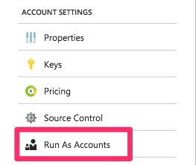

- Select 'Azure Run As Account'

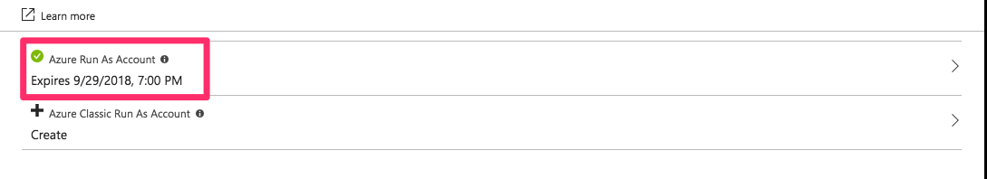

- Locate the Display Name

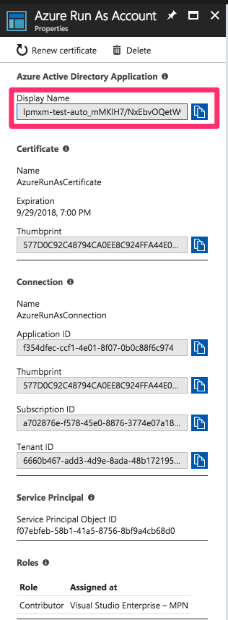

- Once the Display Name has been located. Navigate to the Azure AD section of the Azure portal. Azure AD -> App Registration -> Select the name of the AppID you just found in Step 4 above. Then grant the permissions to the AppID as detailed here. [http://www.gi-architects.co.uk/2017/02/azure-ad-authentication-connect-azuread-in-azure-automation/]

Your AppID that will be running the Powershell script should now have the appropriate
permissions to query Azure AD.

**Note: The user granting permissions to the AzureRunAs user will themselves need
elevated privileges to do so. You may need to enlist the help of an Azure AD administrator
to grant the privileges if you, yourself, receive and error when granting permissions.**

Creating an Azure Automation Runbook

The steps for creating an Azure Automation Runbook are well documented. The directions for getting the SP
Monitor Script turned into a Runbook can be found here [https://docs.microsoft.com/en-us/azure/automation/automation-creating-importing-runbook]. Since the script has already been created, you will need to follow the directions for "Importing a runbook from a file...". Once imported the job should be tested. Once tested you can proceed onto scheduling the job.

Scheduling an Azure Automation Job

Follow the steps below to schedule the runbook. First navigate to the correct section of the portal
Automation Accounts -> {Select the correct Automation Account} -> Runbooks -> {Select the correct
Runbook}.

1. Select Schedule a Runbook
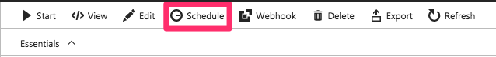

2. Select 'Link a Schedule'

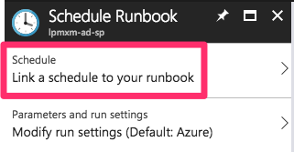

- Create a New Schedule

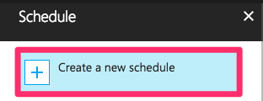

- Fill in the Schedule details and the 'Create'

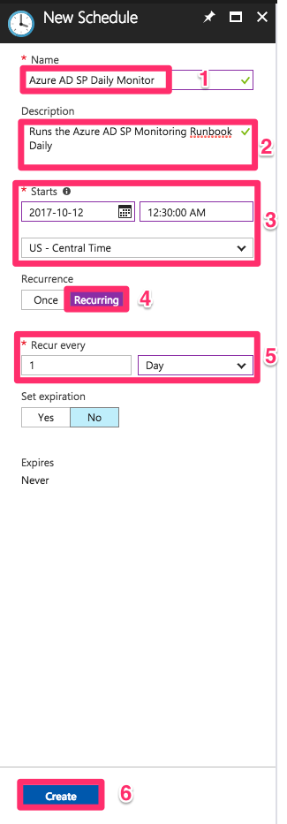

- Select Modify Parameters

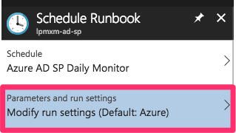

- Set the Parameters by accepting the defaults

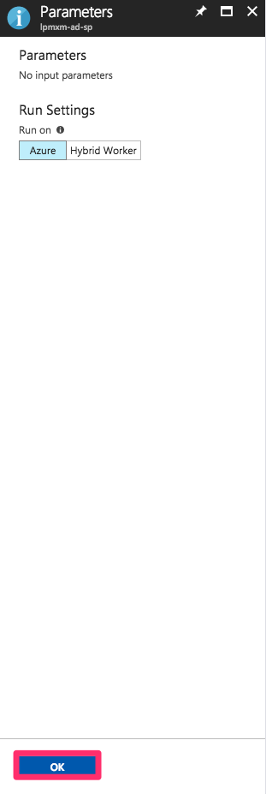

7. Check the schedules
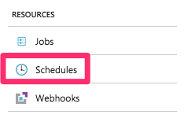

- Verify the Schedule is set for the Runbook

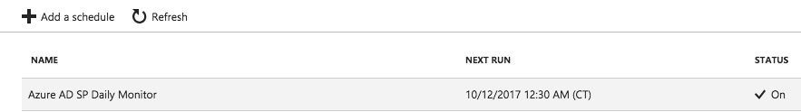

OMS Integration

In order to get the output of the SP Monitor Runbook into Log Analytics you must first turn on diagnostics for the Azure Automation account. Here is an example of how to do so:

Once completed, details, including job outputs, from Azure Automation jobs will begin flowing into Log Analytics. More information can be found in the Azure documentation here.[ https://docs.microsoft.com/en-us/azure/automation/automation-runbook-output-and-messages]

Log Analytics

Once job output from the Runbooks have been sent to OMS, you are able to search Log Analytics. Because there are three tiers of reporting on SPs, we will set up three separate queries and then configure alerts for each of them.

SPs expiring in X days

- The following will search OMS for the output from the Runbook for SPs expiring in 30 days

SQL
- The following will search OMS for the output from the Runbook for SPs expiring in 5 days

SQL

- The following will search OMS for the output from the Runbook for SPs expiring in 1 days

SQL

Alerts

Once the Log Analytics searches are entered into the OMS query bar, you can create alerts against them. The examples documented below will be done from the OMS console. The following is an example of how to create an alert for SPs expiring in 30 days.

1. Paste the query from above into the Log Analytics search box

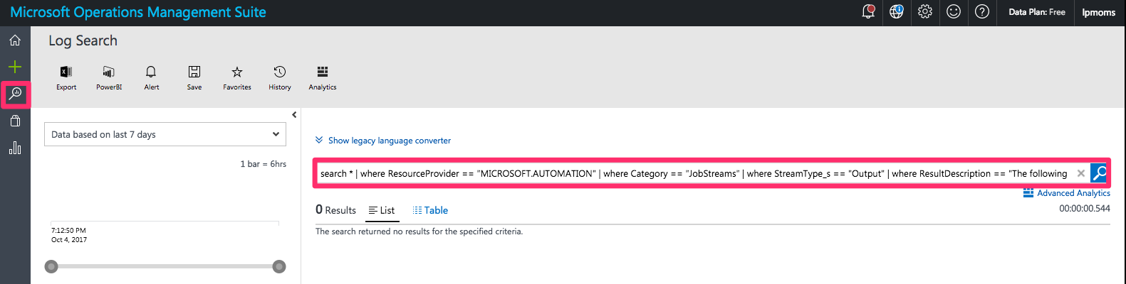

2. You may also wish to test things out via the Advanced Analytics Console e.g.

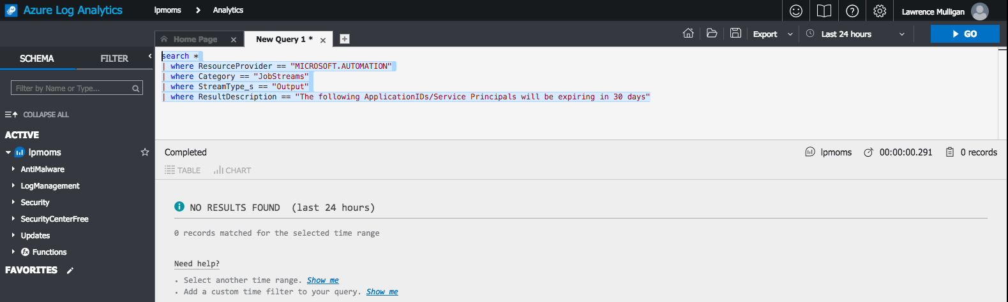
3. Once you are satisfied with the query you can create an alert from search

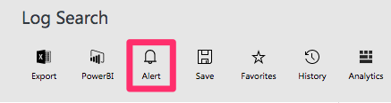

The Alerts panel is divided into three sections (General, Schedule, and Actions). Here is an example of a completed

Alert.

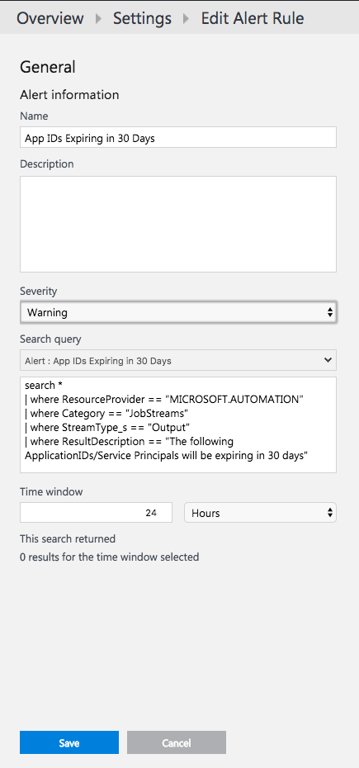

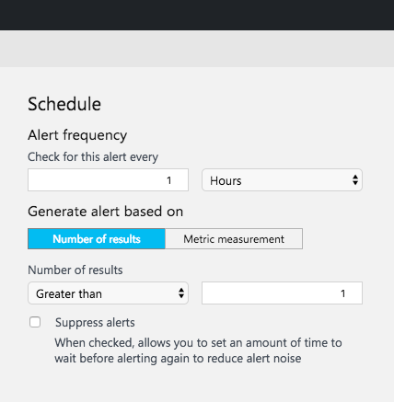

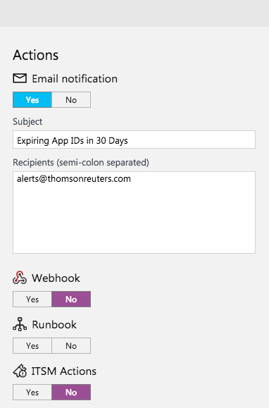

5. Once all sections are completed click on 'Save'

6. Repeat steps 1-5 for the 5 day alert

7. Repeat steps 1-5 for the 1 day alert

